**Jeff Wilson**

**Pandas Week 4**

**Data Tables and Observations**

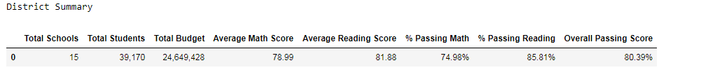

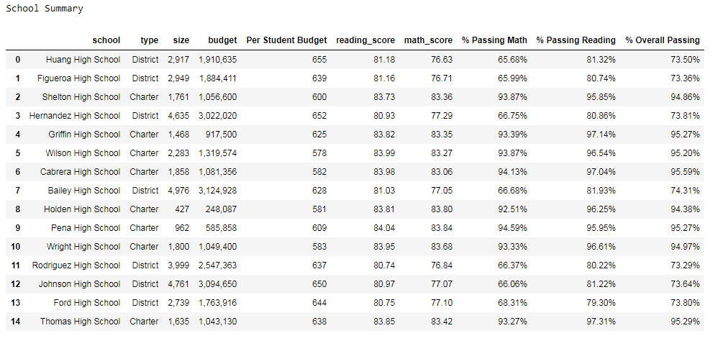

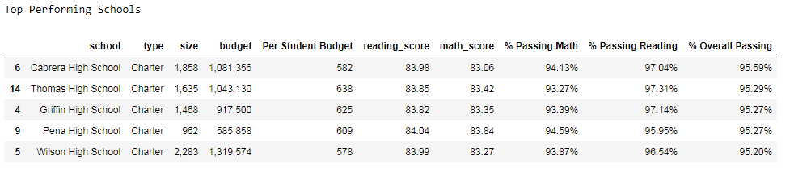

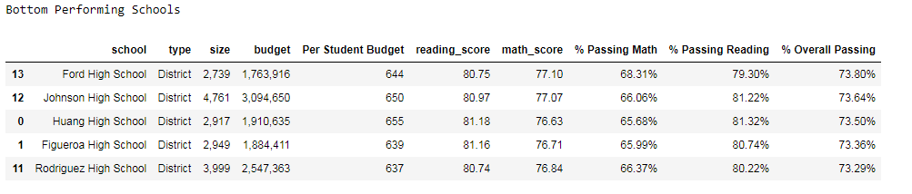

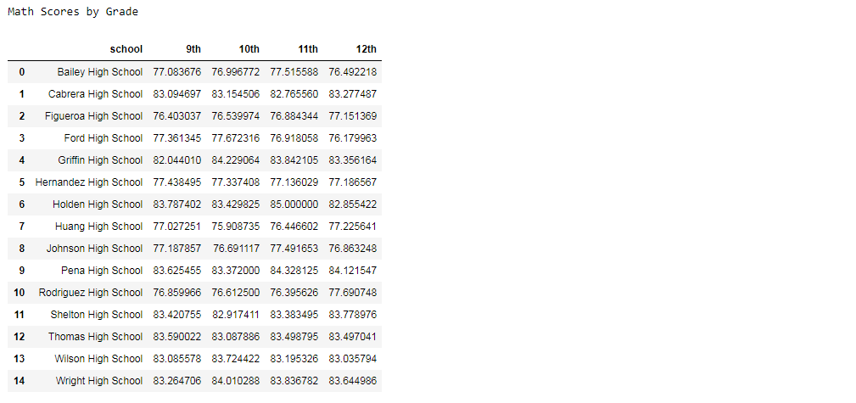

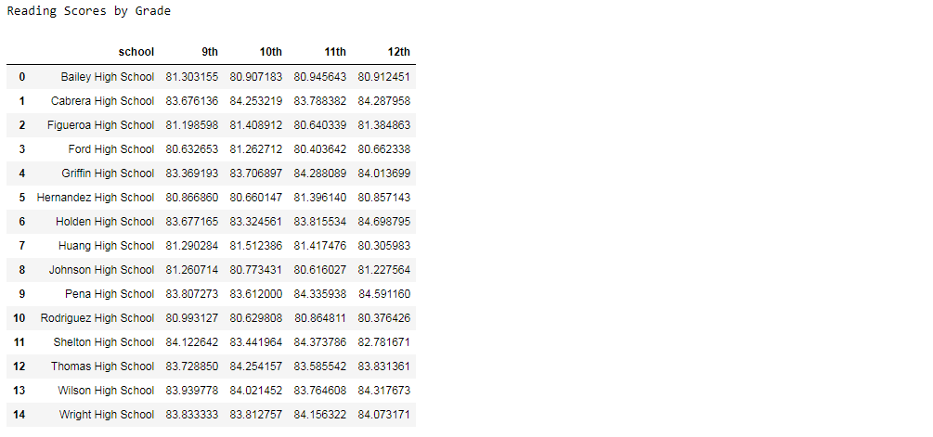



Observation #1: There appears to be an inverse relationship between the school’s per student budget and test scores.



Observation #2: It appears that, generally speaking, smaller schools have higher test scores while the larger schools have lower test scores.



Observation #3: Charter schools have a noticeably higher passing rate, and higher overall test scores.

Comments on observations: In this district, charter schools are smaller while district schools are larger. Charter schools also have smaller per student budgets. The smaller, lower-budget schools are charter schools and they all achieve better test score performance than district schools. There is definitely so correlation in the data but I am not sure which of the three factors is the true driving factor behind these trends. Factors that aren’t captured in the data may be that parents are more involved at charter schools and may be more likely to supplement their children’s education. These parents may also help supplement the school’s budget by providing more supplies, etc. I think more research would need to be done to determine the exact reason or reasons for the test score trends in this school district.